**Seismic Resistant Design of Steel Structures**

**Design Project (Assignment #3)**

R05521203

張世昇

6/5/2017

1. DBE acceleration response spectrum

根據耐震設計規範，依照本次設計作業所提供的場址和結構系統繪製加速度反應譜，並將加速度反應譜正規化至PGA = 0.08g，完成後將加速度反應譜資料匯出至文字檔，在匯入ETABS中的Response Spectrum Function Definition以進行動力分析。

**Acceleration Response Spectrum:**



**Response Spectrum Function Defintion:**

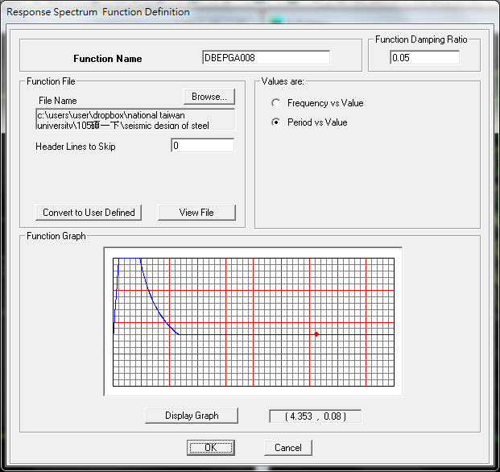

**Response Spectrum Case(x/y direction):**

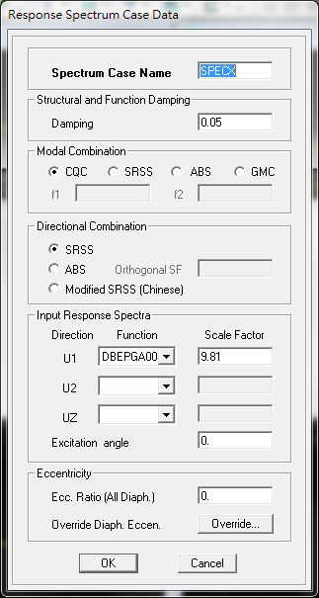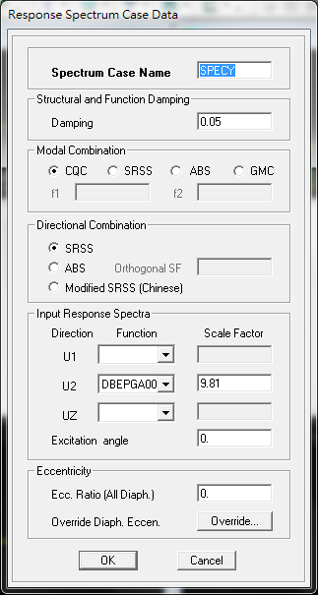

**Analytical result:**

|  |  |  |  |  |
| --- | --- | --- | --- | --- |
| Direction | Base Shear (kgf) | | β | 1/β |
| Static | Dynamic |
| Longitudinal direction | 635771.3 | 390340.8 | 0.614 | 1.629 |
| Transverse direction | 738835.8 | 512815.7 | 0.694 | 1.441 |

CQC base shear in X direction is 390340.8 kgf → βx = 0.614

CQC base shear in Y direction is 512815.7 kgf → βy = 0.694

1. Apply Load Case

根據Assignment#1和Assignment#3所給的資料施加載重。

首先，依照施加載重之需求先繪製相關樓版及梁，但為了不影響本身結構周期在繪製過程中先不指定斷面。並依照題目要求新增3個Load Case (DEAD LOAD、LIVE LOAD、SELF WEIGHT)。

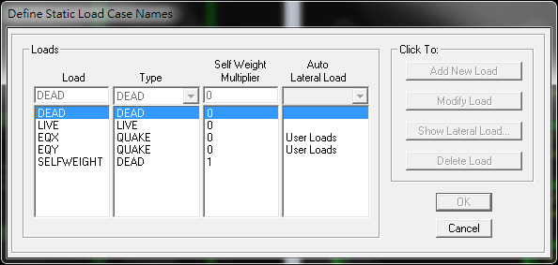

**Case1 DEAD**

**Area uniform load**

RF: Average concrete slab weight + Ceiling, air-condition piping and floor finishing = 280 + 150 = 430kgf/m2

Specially, in the center of the roof(9m×9m is water tank so the weight of center of the roof = 280 + 150 + 1000 = 1430kgf/m2

1F – 3F: Average concrete slab weight + Ceiling, air-condition piping and floor finishing + Partition walls = 280 + 150 + 100 = 530kgf/m2

**Line uniform load**

RF: Exterior walls = 120 × (1.4 + 1.9) = 396kgf/m

1F – 3F: Exterior walls = 120 × 3.8 = 456kgf/m

**Case2 SELF WEIGHT**

**Area uniform load**

The average weight of steel frame (including columns, girders, beams and braces) = 80 = 80kgf/m2

**Case3 LIVE**

**Area uniform load**

Live Load = 250kgf/m2

以RF為例

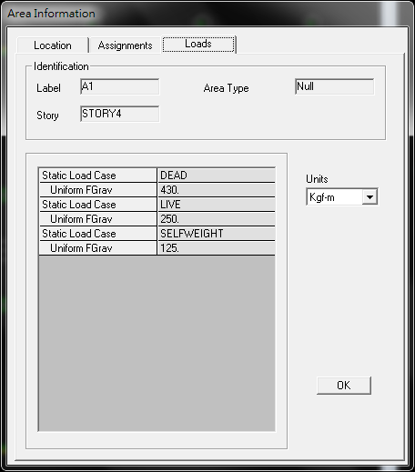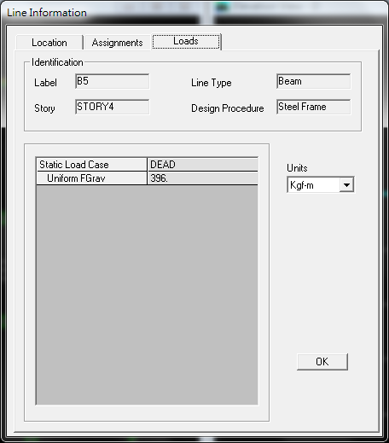

Uniform Load Line Load

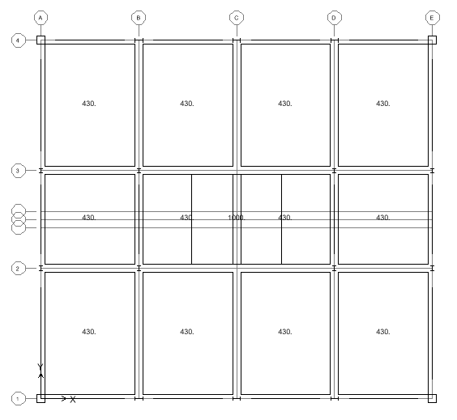

1. Check DCR
2. Live Load Reduction Factor Setting

*Options/Preference/Live Load Reduction*

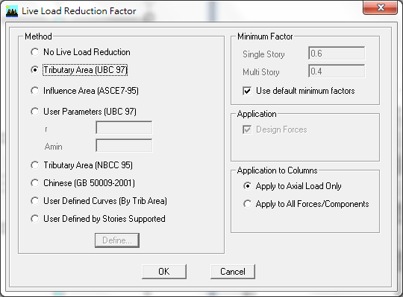

1. Load combinations

|  |  |
| --- | --- |
| **CASE** | **Define Combination** |
| **COMB1** | 1.4DEAD+1.4SELFWEIGHT |
| **COMB2** | 1.2DEAD+1.2SELFWEIGHT+1.6LIVE |
| **COMB3** | 1.2DEAD+1.2SELFWEIGHT+0.5LIVE+1.0EQX |
| **COMB4** | 1.2DEAD+1.2SELFWEIGHT+0.5LIVE+1.0EQY |
| **COMB5** | 1.2DEAD+1.2SELFWEIGHT+0.5LIVE-1.0EQX |
| **COMB6** | 1.2DEAD+1.2SELFWEIGHT+0.5LIVE-1.0EQY |
| **COMB7** | 1.2DEAD+1.2SELFWEIGHT+0.5LIVE+1/βSPECX |
| **COMB8** | 1.2DEAD+1.2SELFWEIGHT+0.5LIVE+1/βSPECY |
| **COMB9** | 1.2DEAD+1.2SELFWEIGHT+0.5LIVE-1/βSPECX |
| **COMB10** | 1.2DEAD+1.2SELFWEIGHT+0.5LIVE-1/βSPECY |

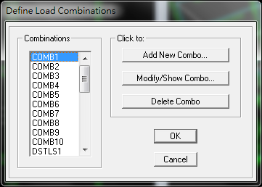

1. Check DCR of MRF

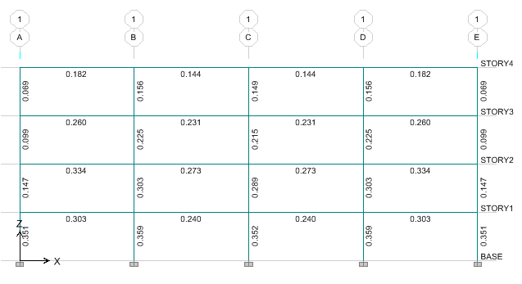

1. Check DCR of BRBF

ETABS預設之壓力強度是以挫曲強度進行計算，所以我們需要修改ㄧ些設計部分的設定。

*Design/Steel Frame Design/View or Revise Overwrites*

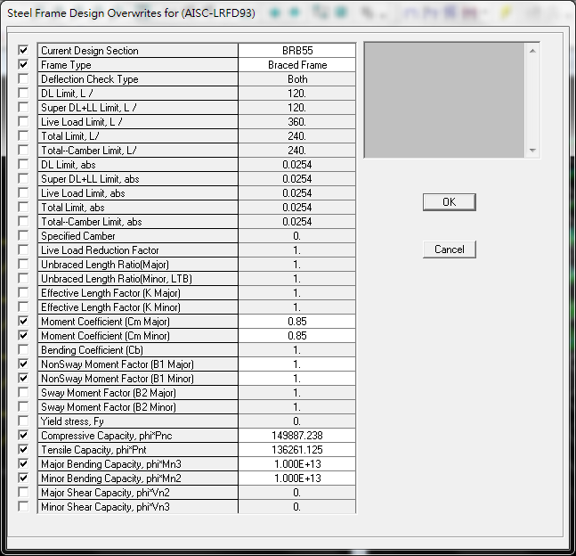

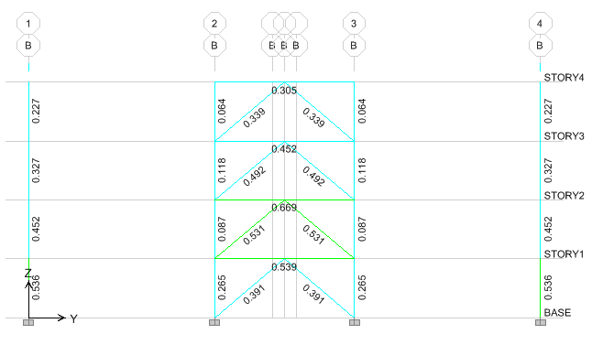

1. Check DCR of EBF

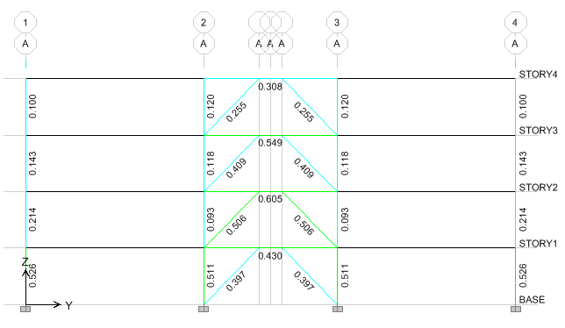

1. Check Inter Story Drifts

|  |  |
| --- | --- |
| Inter Story Drifts | |
|  |  |
| Longitudinal static lateral load | Transversal static lateral load |
|  |  |
| Longitudinal dynamic spectrum load | Transversal dynamic spectrum load |

1. Average of the lateral resisting frame weight

|  |  |  |  |  |  |
| --- | --- | --- | --- | --- | --- |
| Group | SelfMass | SelfWeight | TotalMassX | TotalMassY | TotalMassZ |
| ALL | 22881.84 | 224575.2 | 339329.6 | 339329.6 | 0 |
| 4F | 5604.545 | 55006.15 | 81193.54 | 81193.54 | 0 |
| 3F | 5309.501 | 52110.42 | 85595.74 | 85595.74 | 0 |
| 2F | 6131.419 | 60177.19 | 86417.66 | 86417.66 | 0 |
| 1F | 6131.419 | 60177.19 | 86417.66 | 86417.66 | 0 |

|  |  |
| --- | --- |
| Total structure weight (kgf) | Average structure weight (kgf/m2) |
| 224575.224 | 47.259 |

1. Plot static and dynamic lateral force, story shear and overturning moment distributions. And show the lateral displacements and the inter-story drifts under the static and dynamic (before and after scaling) loads.
2. Frame member size

MRF:

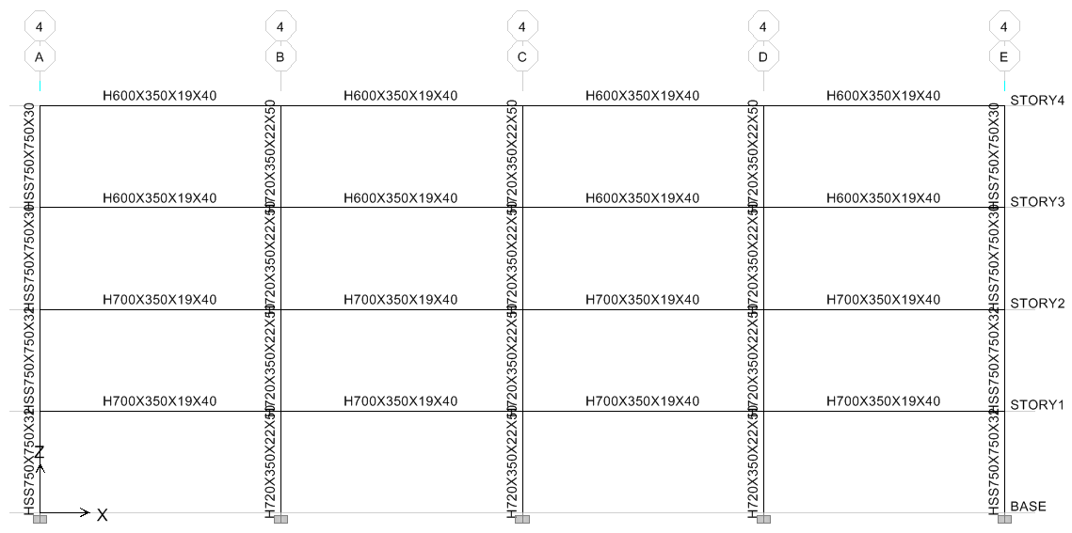

|  |  |  |  |
| --- | --- | --- | --- |
| Story | Beam | Wide Flange Column | Box Column at corner |
| RF | H600×350×19×40 | H720×350×22×50 | HSS750×750×30 |
| 4F | H600×350×19×40 | H720×350×22×50 | HSS750×750×30 |
| 3F | H700×350×19×40 | H720×350×22×50 | HSS750×750×32 |
| 2F | H700×350×19×40 | H720×350×22×50 | HSS750×750×32 |

BRBF:

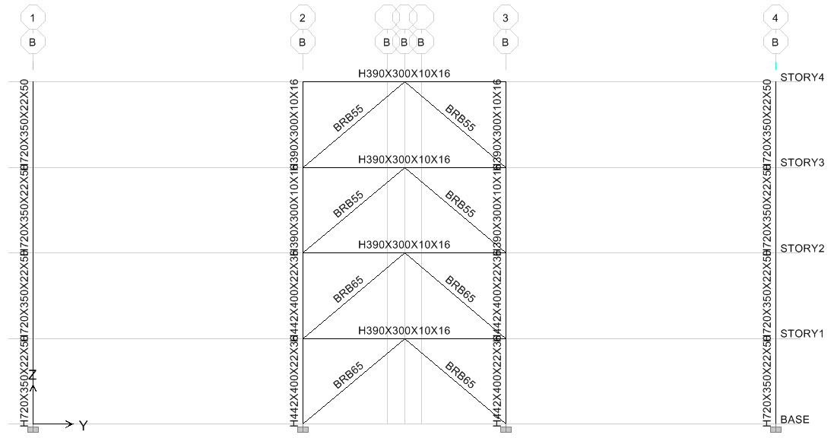

|  |  |  |  |
| --- | --- | --- | --- |
| **Story** | **Beam** | **Wide Flange Column** | **Brace** |
| **RF** | H390×300×10×16 | H390×300×10×16 | Rec55×55 |
| **4F** | H390×300×10×16 | H390×300×10×16 | Rec55×55 |
| **3F** | H390×300×10×16 | H442×400×22×36 | Rec65×65 |
| **2F** | H390×300×10×16 | H442×400×22×36 | Rec65×65 |

EBF:

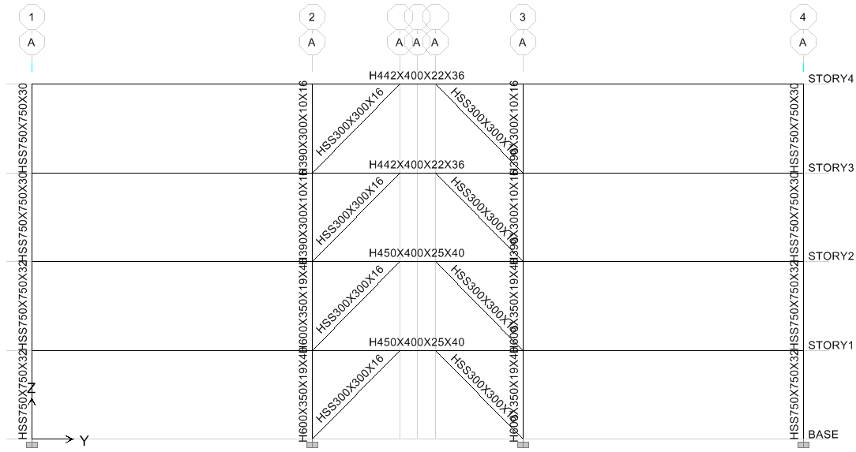

|  |  |  |  |
| --- | --- | --- | --- |
| **Story** | **Beam and Link** | **Wide Flange Column** | **Brace** |
| **RF** | H442×400×22×36 | H390×300×10×16 | HSS300×300×16 |
| **4F** | H442×400×22×36 | H390×300×10×16 | HSS300×300×16 |
| **3F** | H450×400×25×40 | H600×350×19×40 | HSS300×300×16 |
| **2F** | H450×400×25×40 | H600×350×19×40 | HSS300×300×16 |

1. Lateral Force

|  |  |  |  |
| --- | --- | --- | --- |
| Longitudinal Direction Lateral Force(kgf) | | | |
| Story | EQX | SPECX(Before Scaling) | SPECX(After Scaling) |
| RF | 245167.4 | 163061.05 | 265698.3134 |
| 4F | 195301.9 | 112972.94 | 184082.7078 |
| 3F | 130201.3 | 76280.06 | 124293.8353 |
| 2F | 65100.65 | 37863.54 | 61696.39357 |

|  |  |  |  |
| --- | --- | --- | --- |
| Transverse Direction Lateral Force(kgf) | | | |
| Story | EQY | SPECY(Before Scaling) | SPECY(After Scaling) |
| RF | 284911.3 | 205034.43 | 295583.2805 |
| 4F | 226962.2 | 155241.04 | 223799.7582 |
| 3F | 151308.1 | 103687.41 | 149478.6256 |
| 2F | 75654.07 | 48538.2 | 69974.00575 |

1. Story Shear

|  |  |  |  |
| --- | --- | --- | --- |
| Longitudinal Direction Story Shear(kgf) | | | |
| Story | EQX | SPECX(Before Scaling) | SPECX(After Scaling) |
| RF | 245167.4 | 163061.05 | 265698.3134 |
| 4F | 440469.3 | 276033.99 | 449781.0212 |
| 3F | 570670.6 | 352314.05 | 574074.8564 |
| 2F | 635771.3 | 390177.59 | 635771.25 |

|  |  |  |  |
| --- | --- | --- | --- |
| Transverse Direction Story Shear(kgf) | | | |
| Story | EQY | SPECY(Before Scaling) | SPECY(After Scaling) |
| RF | 284911.3 | 205034.43 | 295583.2805 |
| 4F | 511873.5 | 360275.47 | 519383.0387 |
| 3F | 663181.6 | 463962.88 | 668861.6643 |
| 2F | 738835.7 | 512501.08 | 738835.67 |

1. Overturning Moment

|  |  |  |  |
| --- | --- | --- | --- |
| Longitudinal Direction Overturning Moment(kgf-m) | | | |
| Story | EQX | SPECX(Before Scaling) | SPECX(After Scaling) |
| RF | 0 | 0 | 0 |
| 4F | 931636.1 | 619631.991 | 1009653.593 |
| 3F | 2605419 | 1645631.127 | 2681458.355 |
| 2F | 4773968 | 2939472.86 | 4789696.749 |

|  |  |  |  |
| --- | --- | --- | --- |
| Transverse Direction Overturning Moment(kgf-m) | | | |
| Story | EQY | SPECY(Before Scaling) | SPECY(After Scaling) |
| RF | 0 | 0 | 0 |
| 4F | 1082663 | 779130.821 | 1123216.447 |
| 3F | 3027782 | 2132258.125 | 3073922.03 |
| 2F | 5547872 | 3863416.104 | 5569607.045 |

1. Lateral Displacements

|  |  |  |  |
| --- | --- | --- | --- |
| Longitudinal Direction Lateral Displacements(m) | | | |
| Story | EQX | SPECX(Before Scaling) | SPECX(After Scaling) |
| RF | 0.0443 | 0.027 | 0.0440 |
| 4F | 0.0348 | 0.0212 | 0.0345 |
| 3F | 0.0219 | 0.0134 | 0.0218 |
| 2F | 0.0084 | 0.0051 | 0.0083 |

|  |  |  |  |
| --- | --- | --- | --- |
| Transverse Direction Lateral Displacements(m) | | | |
| Story | EQY | SPECY(Before Scaling) | SPECY(After Scaling) |
| RF | 0.0243 | 0.0168 | 0.0242 |
| 4F | 0.0192 | 0.0133 | 0.0192 |
| 3F | 0.0124 | 0.0086 | 0.0124 |
| 2F | 0.0051 | 0.0035 | 0.0050 |

1. Inter-Story Drifts

|  |  |  |  |
| --- | --- | --- | --- |
| Longitudinal Direction Inter-Story Drift(rad) | | | |
| Story | EQX | SPECX(Before Scaling) | SPECX(After Scaling) |
| RF | 0.002501 | 0.001574 | 0.002565 |
| 4F | 0.003372 | 0.002081 | 0.003391 |
| 3F | 0.003572 | 0.002185 | 0.003560 |
| 2F | 0.002203 | 0.001346 | 0.002193 |

|  |  |  |  |
| --- | --- | --- | --- |
| Transverse Direction Inter-Story Drift(rad) | | | |
| Story | EQY | SPECY(Before Scaling) | SPECY(After Scaling) |
| RF | 0.001399 | 0.000987 | 0.001423 |
| 4F | 0.001864 | 0.001302 | 0.001877 |
| 3F | 0.001922 | 0.001338 | 0.001929 |
| 2F | 0.001334 | 0.000926 | 0.001335 |

1. Design gravity gravity beam and gravity girder
2. ETABS

先繪製小梁斷面設計先選擇Auto-Select，並繪製樓版，將設計部分設定為複合梁。

*Design/Overwrite Frame Design Procedure*

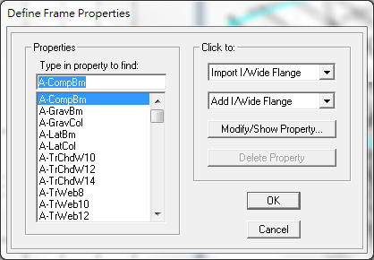 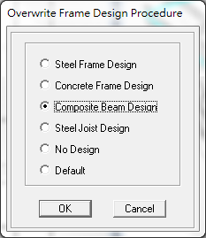

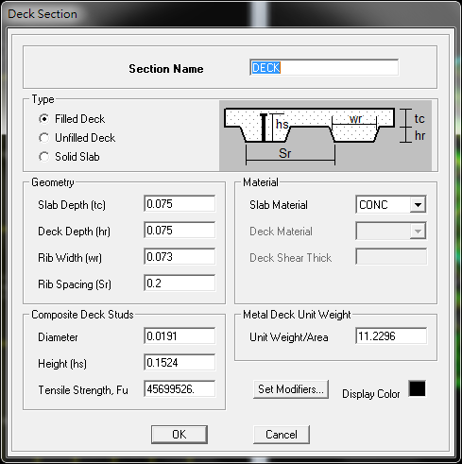 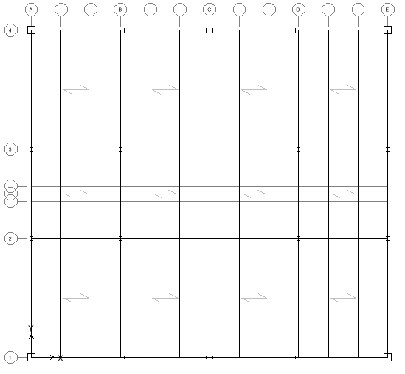

完成設定後，接下來執行*Design/Composite Beam Design/Start Design Using Similarity*進行設計。

Result:

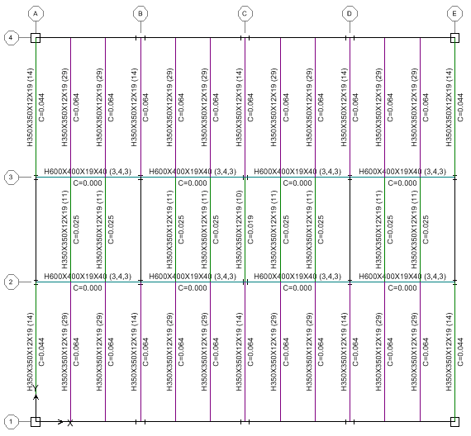

|  |  |
| --- | --- |
| Type | Section |
| Gravity Beam | H350×350×12×19 |
| Gravity Girder | H350×350×12×19、H600×400×19×40 |

剪力釘得直徑為0.0191m，極限強度Fu為45699526.kgf/m2

1. Hand calculations

以下方標記之gravity beam and gravity girder為例

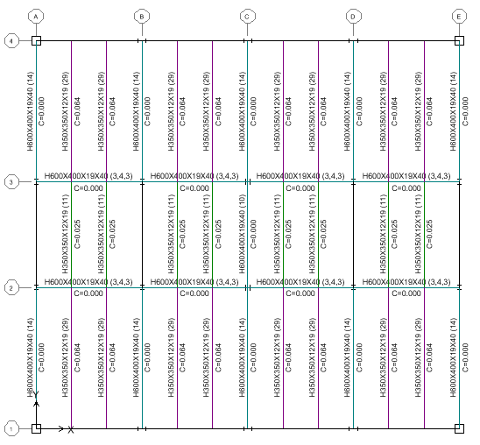

**Gravity Beam**

**(H350X350X12X19 in the interior which is showed in the above picture)**

**Take 2N shear studs equal to 38 for interior gravity beam.**

**Gravity Girder**

**(H600X400X19X40 in the interior which is showed in the above picture)**

**Take 3N shear studs equal to 162 for interior gravity girder.**

**Comparison**

|  |  |  |
| --- | --- | --- |
|  | ETABS | Hand Calculation |
| Gravity Beam | 29 | 38 |
| Gravity Girder | 10 | 162 |

1. Check the average weight of gravity beam and gravity girder

|  |  |  |  |  |
| --- | --- | --- | --- | --- |
| Type | Section | number | Total weight(kgf) | Average weight(kgf/m2) |
| Gravity Beam | H350×350×12×19 | 96 | 140989.454 | 29.67 |
| Gravity Girder | H600×400×19×40 | 76 | 253159.946 | 53.27 |
| Sum | | 172 | 394149.4 | 82.94 |

1. Design the Gravity Columns

Consider the amplification factor of 1.4αy Ra to amplify the lateral force. Therefore, we should consider the P-Δeffect.

1.4αy Ra = 1.4×1×3.533 = 4.95

因此利用ETABS內建之A-GravCol section繪製 Gravity Column.

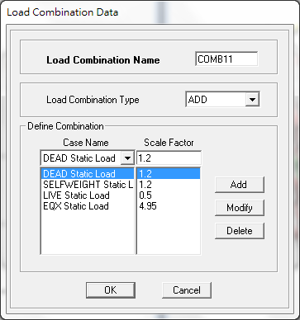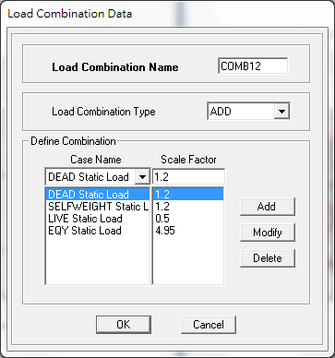

|  |  |
| --- | --- |
| Story | section |
| 3F-4F | H400×408×21×21 |
| 1F-2F | H450×400×25×40 |

Check DCR of Gravity Column:

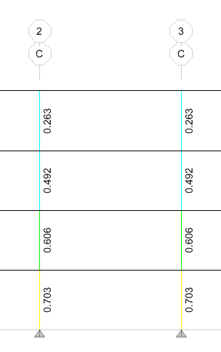

The weight of Gravity Column:

|  |  |  |  |  |
| --- | --- | --- | --- | --- |
| Story | section | number | Total Weight(kgf) | Average Weight(kgf/m2) |
| 3F-4F | H400×408×21×21 | 4 | 2935.499 | 1.235 |
| 1F-2F | H450×400×25×40 | 4 | 4911.551 | 2.067 |

1. Average Total Weight of Steel

|  |  |
| --- | --- |
| Type | Average Weight(kgf/m2) |
| Lateral Load Resisting System | 47.26 |
| Gravity Beam | 29.67 |
| Gravity Girder | 53.27 |
| Gravity Column | 2.07 |
| Sum | 132.27 |

在初步設計時我們假設average weight of steel frame = 80 kgf/m2，設計結果為132.27 kgf/m2，可能原因為設計過度保守，導致鋼材用量過多。但在後續設計過程中我們除了考慮原先假設之自重80 kgf/m2之外也加入鋼材自重，所以在安全上是沒有疑慮的，所以不用重新分析。

**Results of vibration period**

|  |  |  |
| --- | --- | --- |
| **Mode** | **Period (sec)** |  |
| **1** | 0.9284 |  |
| **2** | 0.6259 |  |
| **3** | 0.4744 |  |
| **4** | 0.2834 |  |
| **5** | 0.2167 |  |
| **6** | 0.1565 |  |